Unit 6 Progress Check (College Board Questions)
- Which of the following is recorded in a country’s balance of payments accounts?
A The monthly payments by the country’s residents on domestic loans
B Financial capital flows between the country and the rest of the world
C The value added by each industry in the country at each stage of production
D The aggregate spending of the country’s residents on consumer goods
E Changes in the required reserve ratio determined by the country’s central bank
- Which of the following transactions is recorded as a credit entry in the country’s current account?
A Imports of capital goods
B Exports of consumer goods
C Purchases of foreign government bonds
D Sales of domestic financial assets to foreign investors
E Income transfers from the country’s residents to recipients abroad
- The table shows Country X’s balance of payments data for 2018. Which of the following is true about Country X’s current account balance and financial capital flows?
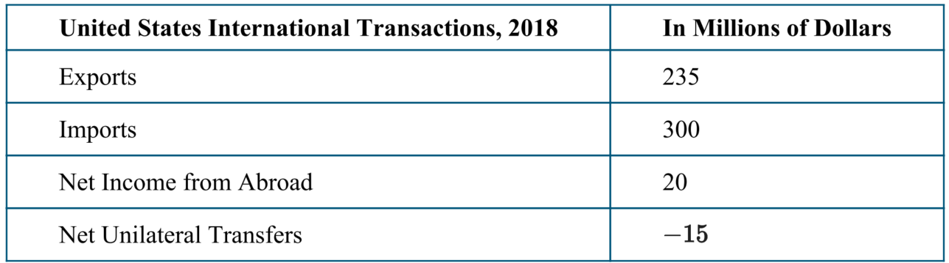
A Country X has a current account deficit of -65 million and has net financial capital inflows.
B Country X has a current account surplus of $65 million and has net financial capital outflows.
C Country X has a current account deficit of -60 million and has net financial capital inflows.
D Country X has a current account surplus of $60 million and has net financial capital outflows.
E Country X has a current account surplus of $5 million and has net financial capital inflows
- Suppose that the exchange rate between the United States dollar ($) and the Thai currency, baht , is 1 baht = $0.05 . Leticia wants to buy a 600baht souvenir from Thailand. What is the souvenir’s price in dollars?
- 0.05
- $1
- $30
- $600
- $12000
- The table shows the exchange rate for the British pound against the dollar and the euro in 2015 and 2018. Which of the following is true?
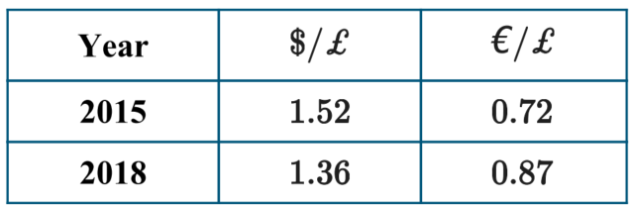
A The dollar has depreciated against the British pound.
B The British pound has depreciated against the dollar.
C The British pound has appreciated against the dollar.
D The British pound has depreciated against the euro.
E The euro has appreciated against the British pound.
- The exchange rate for one Qatari riyal was 0.5 Turkish lira in 2012, and it increased to 1.25 Turkish lira in 2018. Which of the following is true about the value of the Turkish lira in 2018 ?
A 1 Turkish lira 2 Qatari riyal, and the Turkish lira appreciated.
B 1 Turkish lira 1.75 Qatari riyal, and the Turkish lira appreciated.
C 1 Turkish lira 1.25 Qatari riyal, and the Turkish lira depreciated.
D 1 Turkish lira 0.8 Qatari riyal, and the Turkish lira depreciated.
E 1 Turkish lira 0.75 Qatari riyal, and the Turkish lira depreciated.
- If the current exchange rate for one Swiss franc is 0.84 euro and the equilibrium exchange rate for one Swiss franc is 0.88 euro, which of the following will occur in the flexible exchange market for the Swiss franc?
A There will be a shortage of euros.
B There will be a surplus of Swiss francs.
C The euro will appreciate.
D The Swiss franc will depreciate.
E The Swiss franc will appreciate
- The graph shows the foreign exchange market for British pounds . If the exchange rate is $1.70, which of the following is true?
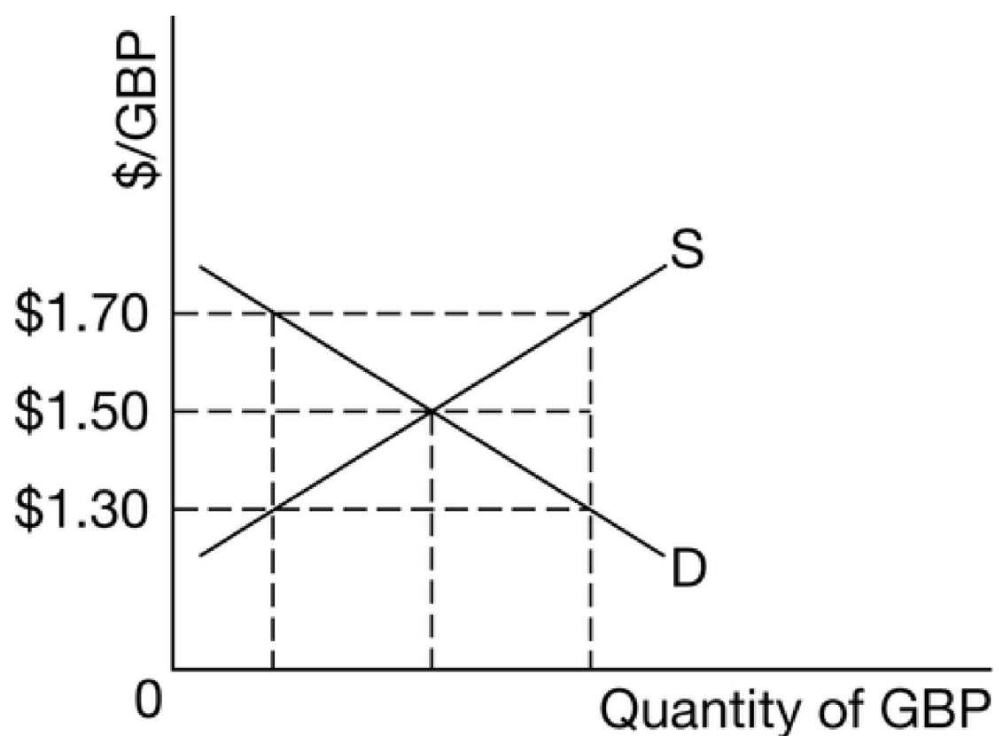
A The British pound is in equilibrium.
B The surplus of British pounds will cause the exchange rate to depreciate.
C The shortage of British pounds will cause the exchange rate to depreciate.
D The surplus of British pounds will cause the exchange rate to appreciate.
E The shortage of British pounds will cause the exchange rate to appreciate.
- Which of the following graphs correctly illustrates the equilibrium exchange rate of 1 Swedish krone = 0.5 Mexican peso?
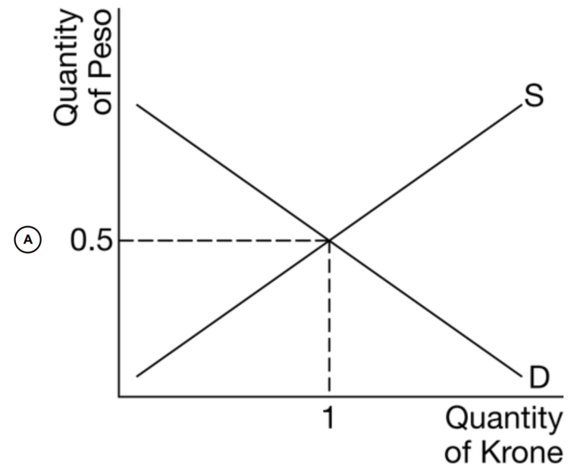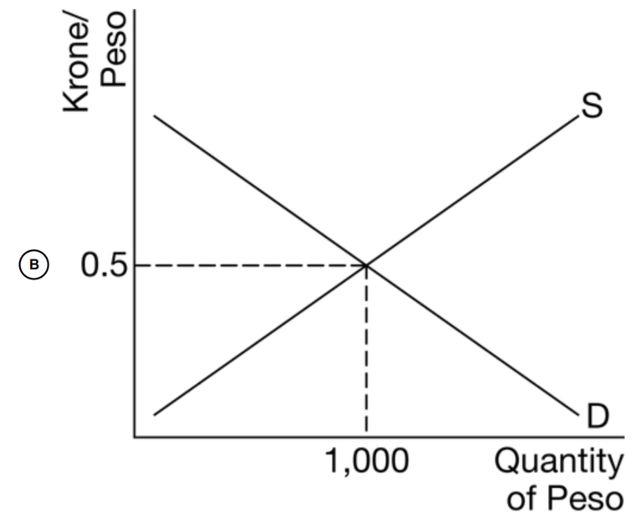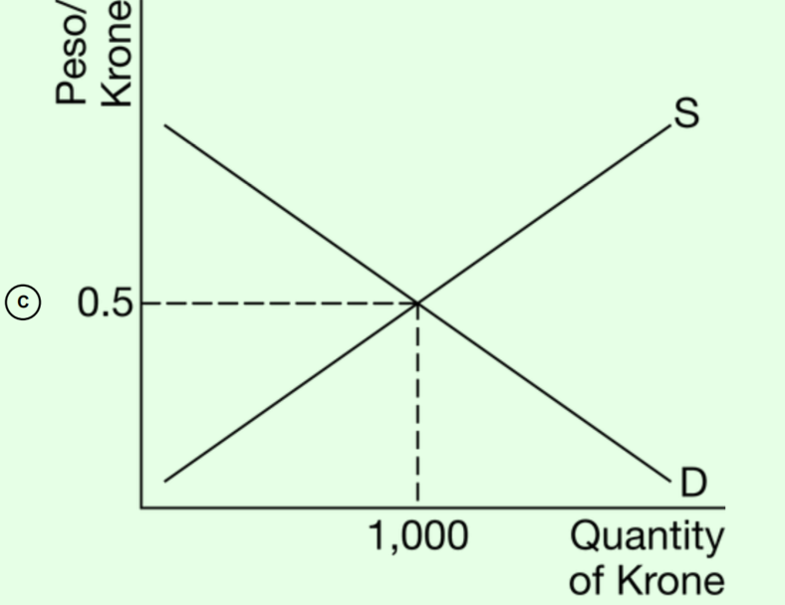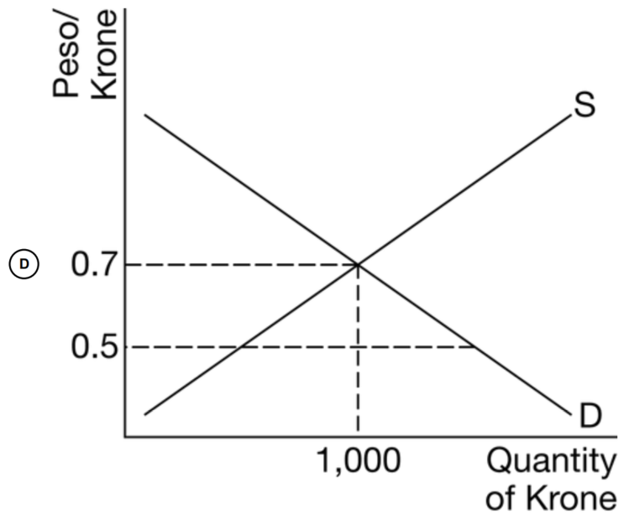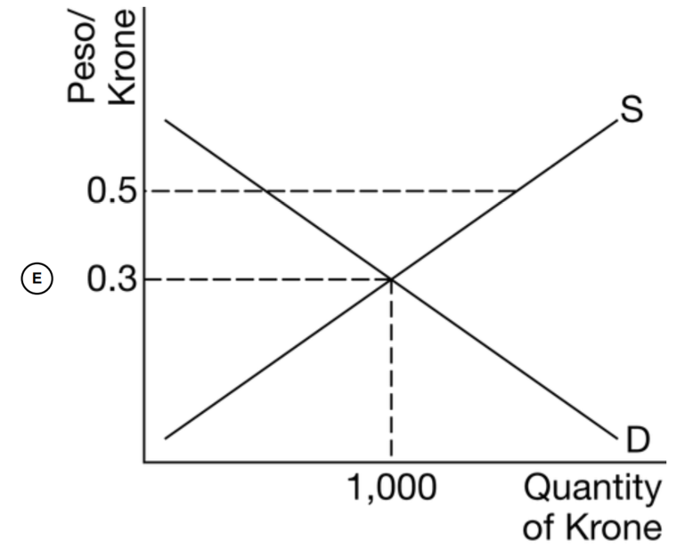
- Assuming the government of a country imposes a tariff on its imports of foreign goods, what is the likely effect on the country’s currency in foreign exchange markets?
A The supply of the currency will increase and the currency will depreciate.
B The supply of the currency will increase and the currency will appreciate.
C The supply of the currency will decrease and the currency will appreciate.
D The demand for the currency will decrease and the currency will appreciate.
E The demand for the currency will increase and the currency will depreciate.
- Assume Country X’s economy is experiencing high rates of inflation. Which of the following policies will control the problem of inflation, and what is the consequent effect on the value of Country X’s currency in foreign exchange markets?
A A contractionary monetary policy will increase interest rates, which will cause the currency to depreciate.
B A contractionary monetary policy will increase interest rates, which will cause the currency to appreciate.
C An expansionary monetary policy will decrease interest rates, which will cause the currency to appreciate.
D An expansionary monetary policy will decrease interest rates, which will cause the currency to depreciate.
E An expansionary monetary policy will increase interest rates, which will cause the currency to depreciate
- Assume that a nation’s government uses an expansionary fiscal policy to restore full employment. What effect will the resulting change in the price level have on the supply and demand of the nation’s currency in the foreign exchange market?
A The supply and demand will both increase.
B The supply and demand will both decrease.
C The supply will increase and the demand will decrease.
D The supply will decrease and the demand will increase.
E The supply will not change and the demand will decrease.
- Which of the following will happen to aggregate demand in the United States if the United States dollar appreciates in foreign exchange markets?
A Aggregate demand will decrease because net exports will decrease.
B Aggregate demand will decrease because imports will decrease.
C Aggregate demand will increase because exports will increase.
D Aggregate demand will increase because imports will decrease.
E Aggregate demand will increase because exports will decrease
- Which of the following changes in the United States will most likely increase aggregate demand in Japan?
A decrease in the United States real gross domestic product
B A decrease in the United States price level
C A quota imposed by the United States on goods imported from Japan
D An appreciation of the United States dollar relative to the yen
E An increase in the demand for Japanese financial assets by American investors
- Suppose that Angola’s economy is booming resulting in an increase in the income of domestic residents. How will the increase in income most likely affect the foreign exchange value of the Angolan currency, the kwanza, and the Angolan net exports?
A The kwanza will appreciate and net exports will increase.
B The kwanza will appreciate and net exports will decrease.
C The kwanza will depreciate and net exports will increase.
D The kwanza will depreciate and net exports will decrease.
E The kwanza will depreciate and net exports will not change.
- How will an increase in private savings in the United States most likely affect financial capital flows and the value of the dollar in foreign exchange markets?
A The United States will experience financial capital inflows, and the dollar will appreciate.
B The United States will experience financial capital inflows, and the dollar will depreciate.
C The United States will experience financial capital outflows, and the dollar will appreciate.
D The United States will experience financial capital outflows, and the dollar will depreciate.
E The United States will experience no change in financial capital flows, and the value of the dollar will not change
- The loanable funds markets in Japan and Australia are in equilibrium, as shown in the graphs above. Which of the following is most likely to happen?
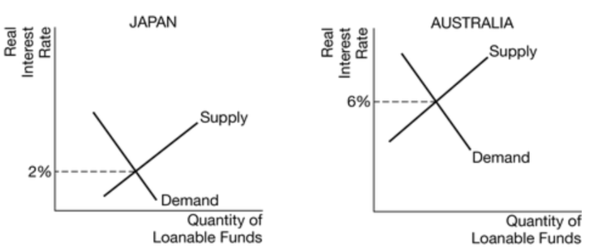
There will be financial capital outflows from Australia to Japan, and the Japanese yen will depreciate.
B There will be financial capital outflows from Australia to Japan, and the Japanese yen will appreciate.

Answers
1 | B | 6 | D
2 | B | 7 | E
3 | C | 8 | B
4 | C | 9 | C
5 | B | 10 | C
 |  |  |  |  | 11 | B | 16 | D
 |  |  |  |  | 12 | C | 17 | D
 |  |  |  |  | 13 | A | 18 | A
 |  |  |  |  | 14 | D
 |  |  |  |  | 15 | D

C There will be financial capital outflows from Japan to Australia, and the Australian dollar will depreciate.
D There will be financial capital outflows from Japan to Australia, and the Australian dollar will appreciate.
E There will be no change in financial capital flows between Australia and Japan, keeping the foreign exchange rate unchanged
- Which of the following will most likely cause an inflow of financial capital to Canada?
A An increase in the Canadian federal budget deficit
B An increase in the Canadian money supply
C An increase in private savings in Canada
D An increase in taxes on investment in plant and equipment
E An increase in real interest rates of Canada’s trading partners

